Themenblock 4: Food Trends & Nutrition

TASK SET A1

From Scratch to Click – The Changing Kitchen

PART 1 — Individual Long Turn
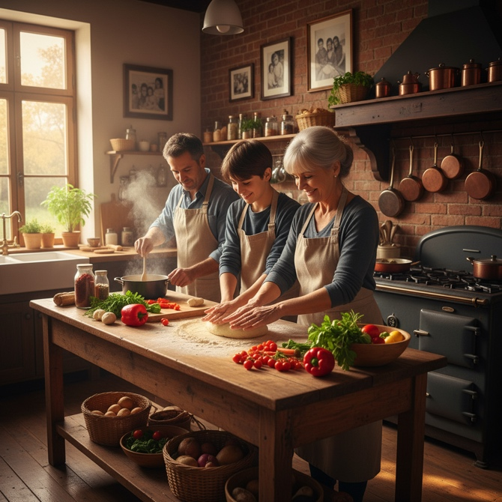
Task
Give a five-minute talk on changing food preparation habits in which you
- describe, compare and contrast the pictures above.
- analyze the advantages and disadvantages of both approaches to food preparation.
- discuss how these changes affect family traditions and cooking skills in modern society.

PART 2 — Paired Activity
Task
Your school wants to offer an after-school cooking club to help students develop practical food preparation skills. You and your partner are on the planning committee. Discuss the following options and agree on THREE to include in the program:
- Quick healthy meals for busy students
- Traditional Austrian recipes
- International cuisines from students' backgrounds
- Budget cooking on a student income
- Plant-based and vegetarian cooking

TASK SET A2

Waste Not, Want Not – The Food Rescue Movement

PART 1 — Individual Long Turn
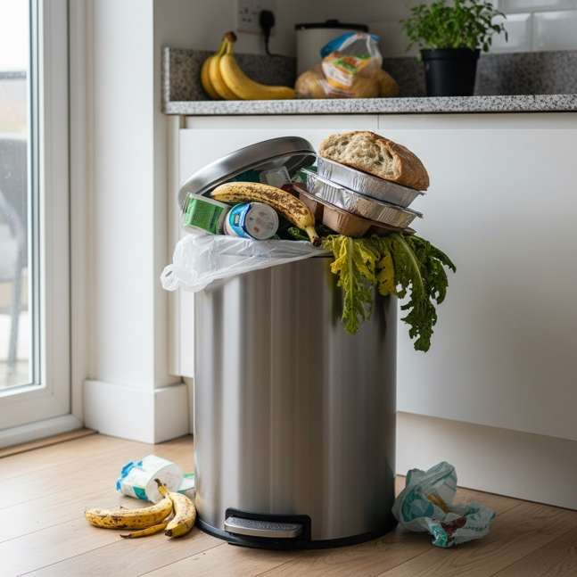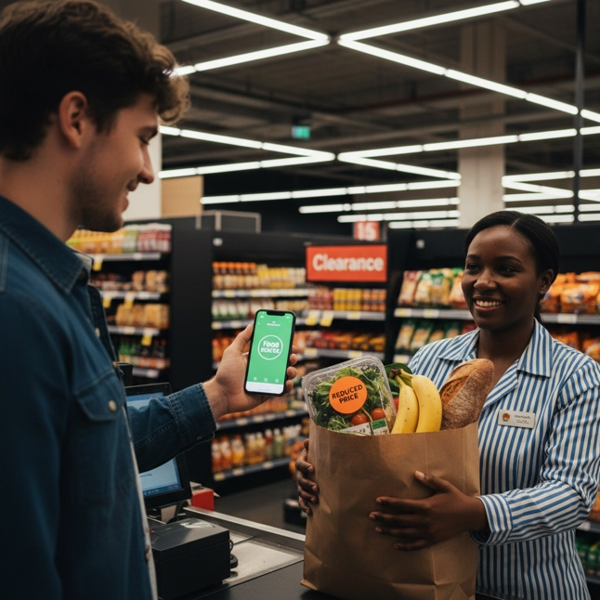
Task
Give a five-minute talk on food waste and food rescue in which you
- describe, compare and contrast the pictures above.
- evaluate the causes and consequences of food waste in modern households.
- suggest practical measures individuals and communities can take to reduce food waste.

PART 2 — Paired Activity
Task
Your class wants to launch a 'Zero Waste Week' campaign at school. You and your partner need to plan activities to raise awareness and change behavior. Discuss the following ideas and agree on THREE to implement:
- A 'weigh your waste' competition between classes
- Cooking workshop using 'leftover' ingredients
- Information posters about food date labels
- Partnership with local food rescue organization
- Student-run 'share table' in the cafeteria

TASK SET A3

#FoodPorn vs. Real Life – Social Media and Eating

PART 1 — Individual Long Turn
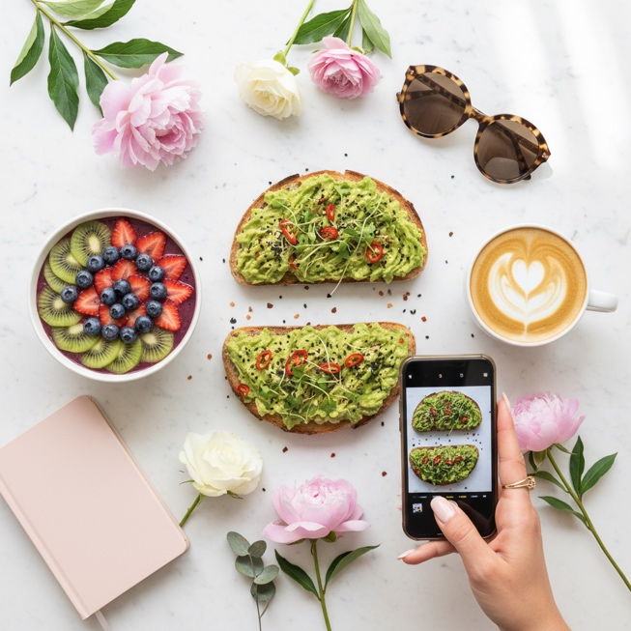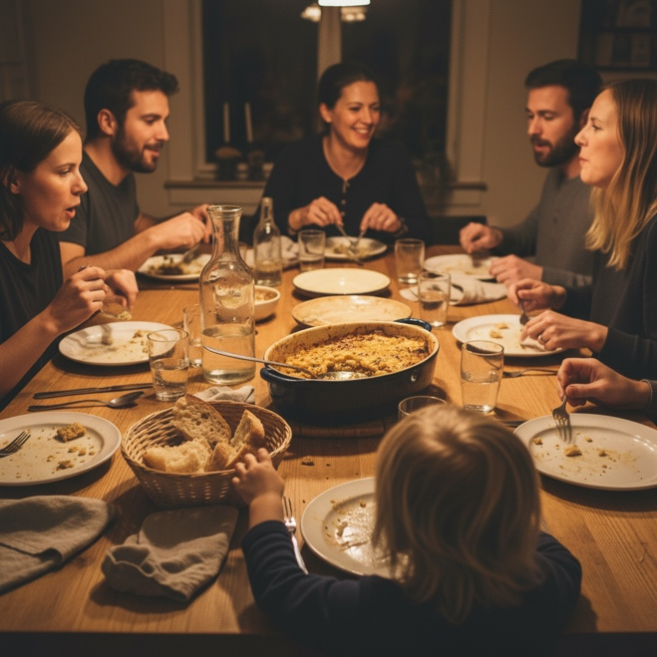
Task
Give a five-minute talk on social media's influence on our relationship with food in which you
- describe, compare and contrast the pictures above.
- analyze how social media has changed the way young people think about and experience food.
- comment on whether this development is positive or negative for health and wellbeing.

PART 2 — Paired Activity
Task
A local youth magazine wants to publish a special issue on 'Young People and Food.' You and your partner are guest editors deciding on content. Discuss the following article ideas and agree on THREE to include:
- 'The truth behind food influencers' – exposing staged content
- 'Cooking on a student budget' – practical tips and recipes
- 'My grandmother's kitchen' – traditional recipes making a comeback
- 'Why I stopped counting calories' – a personal story
- 'The rise of plant-based eating' – trend or lifestyle change?

TASK SET B1

What Food Means – Philosophy and Identity

PART 1 — Individual Long Turn
Quote 1:
"Eat food. Not too much. Mostly plants."
— Michael Pollan, In Defense of Food: An Eater's Manifesto (2008)
Quote 2:
"Food is everything we are. It's an extension of nationalist feeling, ethnic feeling, your personal history, your province, your region, your tribe, your grandma. It's inseparable from those from the get-go."
— Anthony Bourdain, chef, author, and television presenter
Task
Give a five-minute talk on what food means in our lives in which you
- analyze and compare the two quotes above and explain what each author means.
- discuss whether food is primarily fuel or cultural identity.
- comment on your own relationship with food and which perspective resonates more with you.

PART 2 — Paired Activity
Task
Your town is planning a 'Food Festival' to celebrate local food culture while promoting healthy eating. You and your partner are on the organizing committee. Discuss the following elements and agree on THREE priorities:
- Traditional local food stalls (Schnitzel, Strudel, regional specialties)
- 'Healthy alternatives' cooking demonstrations
- International food representing the community's diversity
- Children's activities (cooking workshops, vegetable garden)
- Information stands about nutrition and sustainability

TASK SET B2

Health vs. Happiness – The Dieting Dilemma

PART 1 — Individual Long Turn
Quote 1:
"Tell me what you eat, and I will tell you what you are."
— Jean Anthelme Brillat-Savarin, The Physiology of Taste (1825)
Quote 2:
"The only time to eat diet food is while you're waiting for the steak to cook."
— Julia Child, American chef and television personality
Task
Give a five-minute talk on attitudes toward food and dieting in which you
- critically analyze both quotes and explain what each suggests about our relationship with food.
- discuss whether people should prioritize eating for health or eating for pleasure.
- evaluate how modern diet culture affects young people's attitudes toward food and eating.

PART 2 — Paired Activity
Task
Your school's health committee wants to promote a positive relationship with food among students. You and your partner have been asked to develop a 'Healthy Eating Without Dieting' campaign. Discuss the following messages and agree on THREE to include in the campaign:
- Listen to your body's hunger and fullness signals
- All foods can fit into a balanced diet – no food is 'bad'
- Focus on how food makes you feel, not on calories
- Enjoy meals with friends and family without guilt
- Challenge unrealistic body images on social media

TASK SET C1

One Billion Meals Wasted Daily – The Global Food Waste Crisis

PART 1 — Individual Long Turn
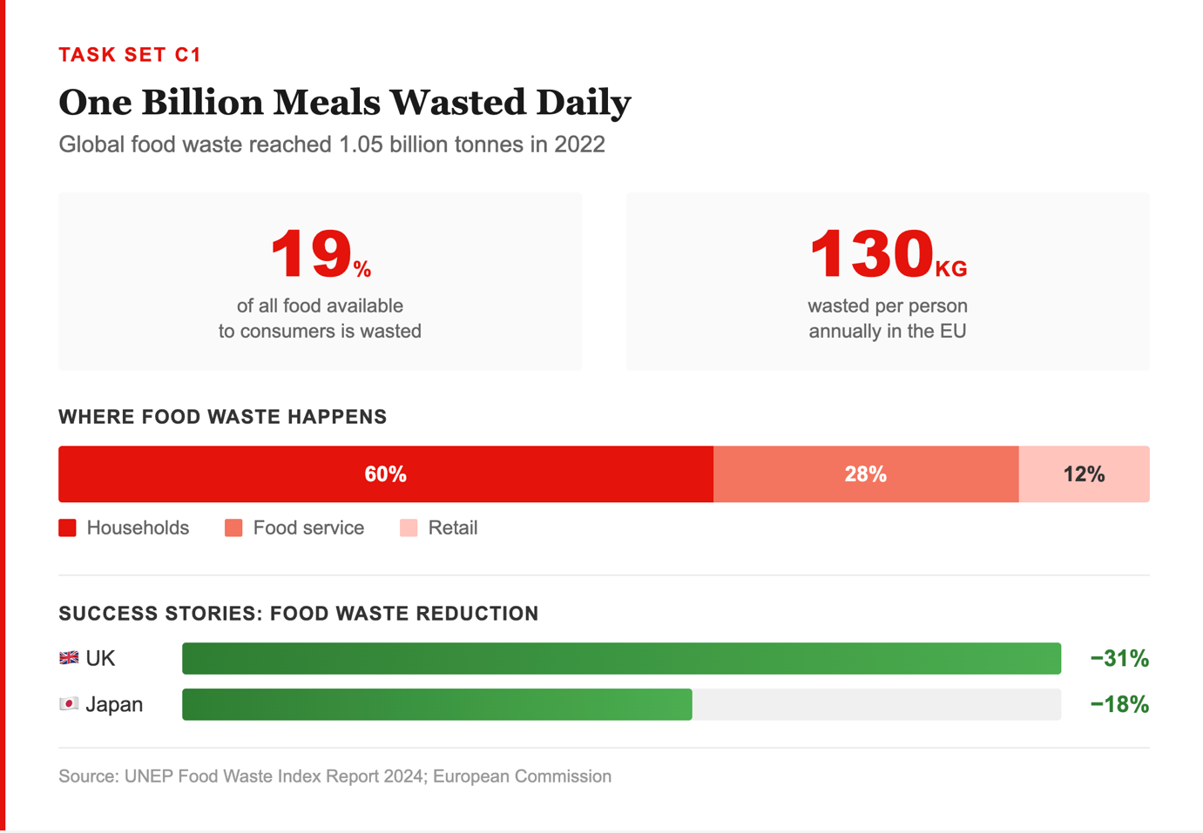
Task
Give a five-minute talk on the global food waste crisis in which you
- explain the key statistics from the text extract and what they reveal about our food system.
- analyze why households are the biggest source of food waste and what factors contribute to this.
- discuss what can be learned from successful countries.

PART 2 — Paired Activity
Task
Your local government wants to launch a food waste reduction campaign inspired by the UK's success. You and your partner are consultants advising on the strategy. Discuss the following approaches and agree on THREE to recommend:
- Public awareness campaign (TV, social media, posters)
- School education program on food waste
- Incentives for supermarkets to donate unsold food
- Community composting facilities
- App connecting households with surplus food to neighbors

TASK SET C2

The Plant-Based Revolution – Changing How We Eat

PART 1 — Individual Long Turn
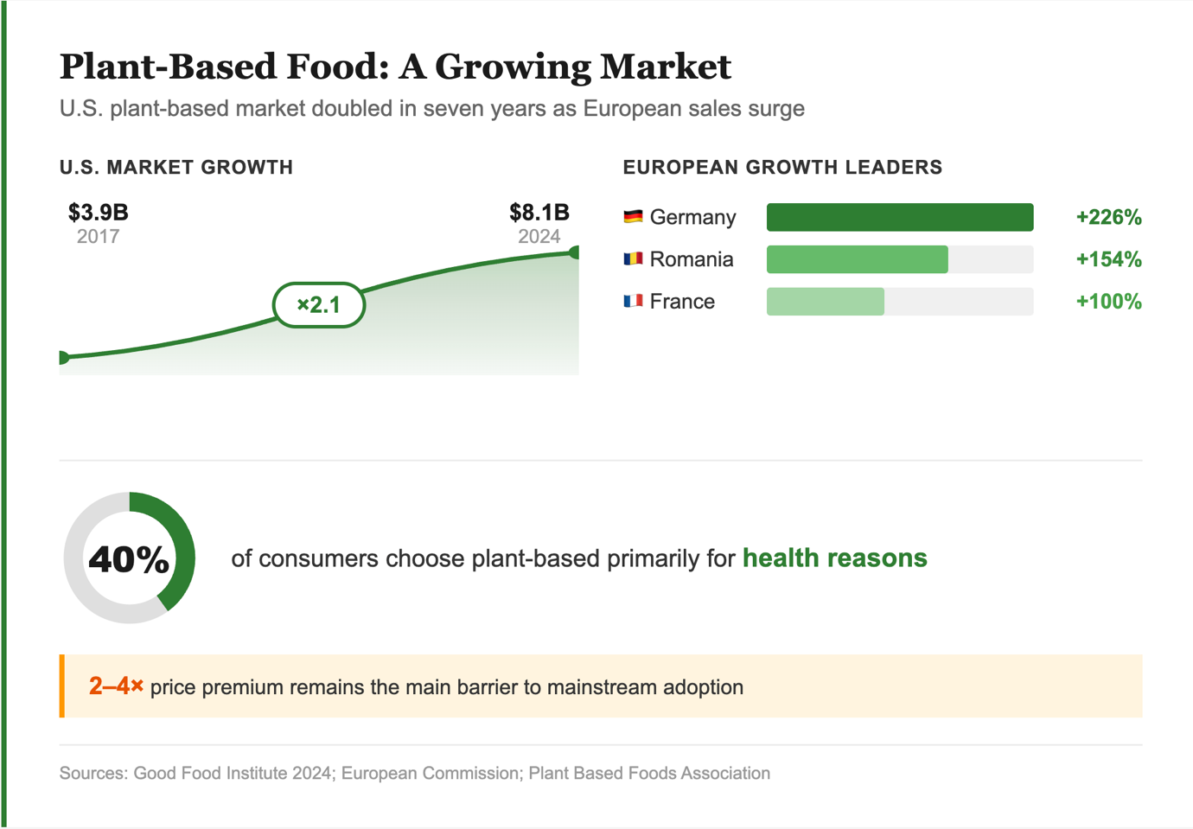
Task
Give a five-minute talk on the rise of plant-based eating in which you
- explain what the statistics reveal about changing food habits and why this trend is growing.
- evaluate the benefits and challenges of plant-based diets for individuals and society.
- comment on whether plant-based eating will become mainstream.

PART 2 — Paired Activity
Task
Your school cafeteria wants to introduce more plant-based options. You and your partner have been asked to advise on the best approach. Discuss the following strategies and agree on THREE to recommend:
- Offer one fully plant-based day per week (e.g., 'Meatless Monday')
- Add plant-based versions of popular dishes (burgers, schnitzel, curry)
- Label dishes with environmental impact information
- Price plant-based options competitively with meat options
- Organize taste-testing events to introduce new options

